.NET Framework 3.5 installation error: 0x800F0906, 0x800F081F, 0x800F0907

Configure the Group Policy setting
This behavior can also be caused by a system administrator who configures the computer to use Windows Server Update Services (WSUS) instead of the Microsoft Windows Update server for servicing. In this case, contact your system administrator and request that they enable the Specify settings for optional component installation and component repair Group Policy setting and configure the Alternate source file path value or select the Contact Windows Update directly to download repair content instead of Windows Server Update Services (WSUS) option.
To configure the Group Policy setting, follow these steps:
- Start the Local Group Policy Editor or Group Policy Management Console.
Windows 8 and Windows Server 2012: Point to the upper-right corner of the screen, click Search, type group policy, clickSettings, and then click Edit group policy.
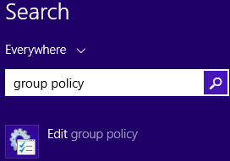
Windows 8.1 and Windows Server 2012 R2: Point to the upper-right corner of the screen, click Search, type group policy, and then click Edit group policy.
- Expand Computer Configuration, expand Administrative Templates, and then select System. The screen shot for this step is listed below.
Expand this image
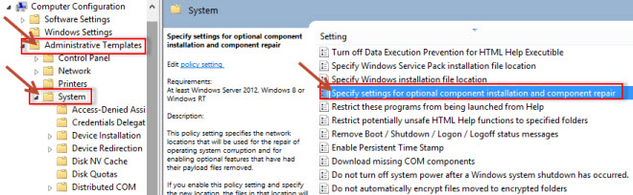
- Open the Specify settings for optional component installation and component repair Group Policy setting, and then select Enabled. The screen shot for this step is listed below.
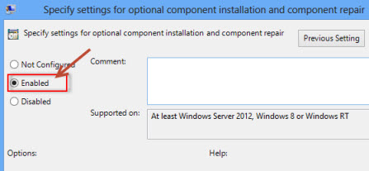
- If you want to specify an alternative source file, in the Alternate source file path box, specify a fully qualified path of a shared folder that contains the contents of the \sources\sxs folder from the installation media.
Example of a shared folder path: \\server_name\share\Win8sxs
Or, specify a WIM file. To specify a WIM file as an alternative source file location, add the prefix WIM: to the path, and then add the index of the image that you want to use in the WIM file as a suffix.
Example of a WIM file path: WIM:\\server_name\share\install.wim:3
Note In this example, 3 represents the index of the image in which the feature files are found.
- If it is applicable to do this, select the Contact Windows Update directly to download repair content instead of Windows Server Update Services (WSUS) check box.
- Tap or click OK.
- At an elevated command prompt, type the following command, and then press Enter to apply the policy immediately:
gpupdate /force

